1. It must be free ( without any payment anyone can use it.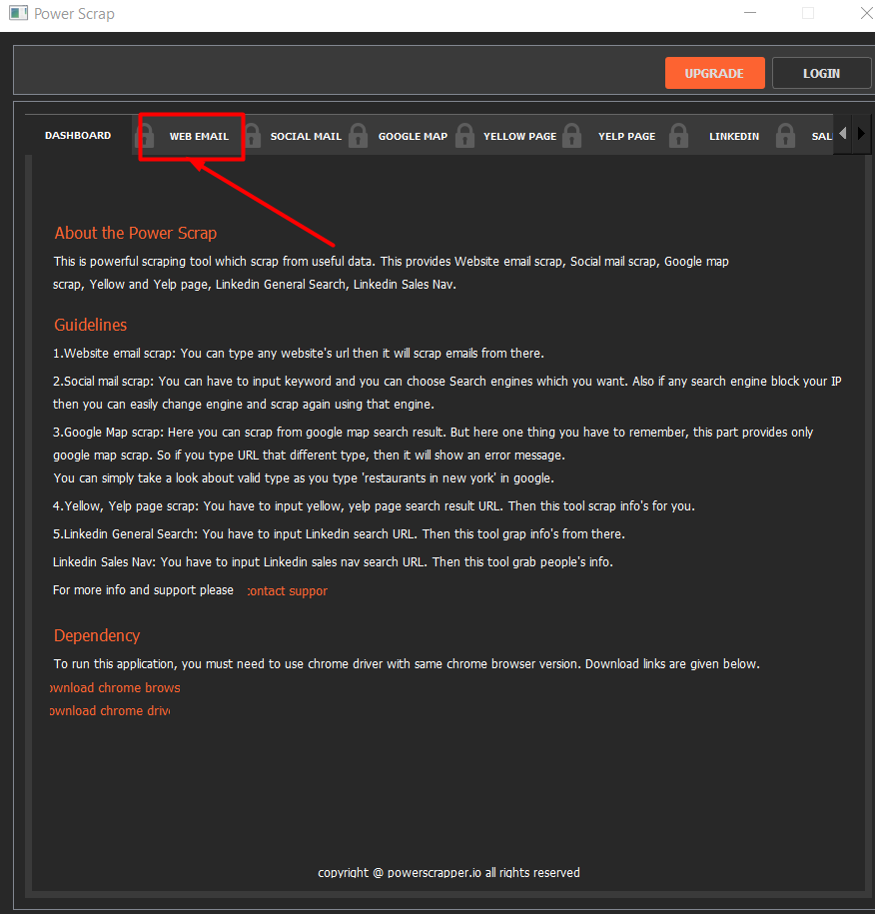
2. Too much slower than others

( refenace extension: <https://chrome.google.com/webstore/detail/email-extractor/jdianbbpnakhcmfkcckaboohfgnngfcc?hl=en>)

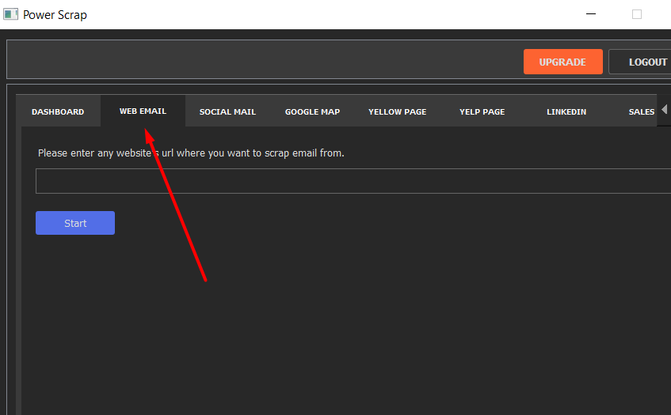

1. Need to check output file for Social Email scraping ( just need upto user name for title column) also need to remove some unnecessary character in source colum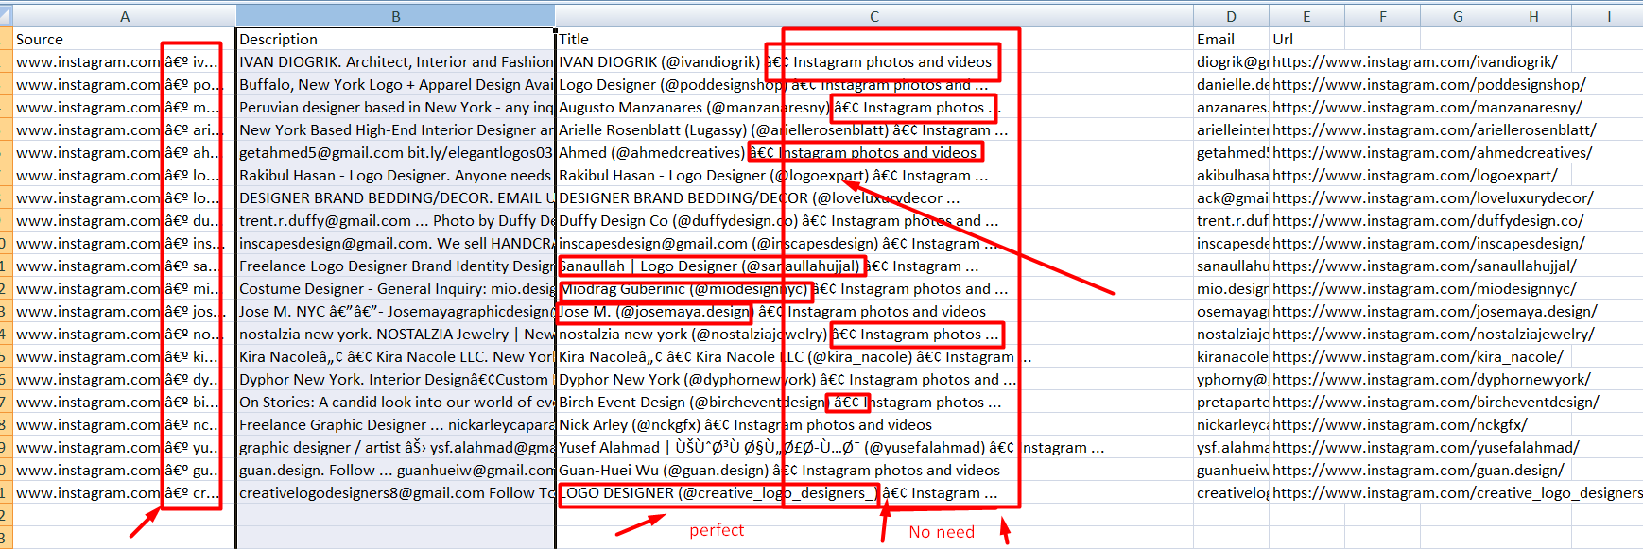
2. Google maps not working
3. Yelp also not working
4. Yellow supper slow
5. For Linkedin (both general and Sales) title column just need to add before “at”





1. After complete scrape it going close but need to perform for another scrape or open